### **Steps to submit soft copy invoice submission**

User should follow the below steps to upload soft copy:

* Go to [MS invoice](https://einvoice.microsoft.com/Default.aspx?MSIStateKey=47d14cc6-d5e3-4c18-ab62-395a3aa491a1)
* Select Supplier ID – Click ‘OK’
* Select company code
* Click on ‘**Submit a soft copy invoice**’

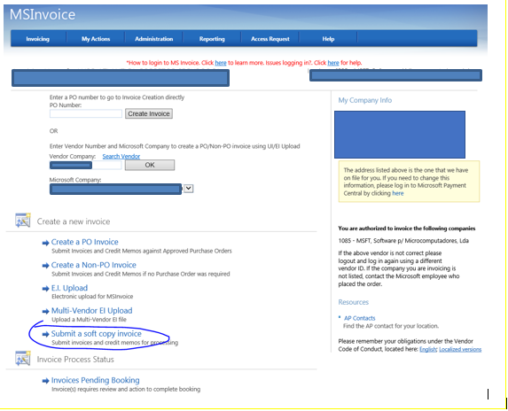

* Fill the below fields
  + Supplier/Payee Invoice Number
  + Transaction Type – Invoice/Credit
  + Invoice Type – Purchase Order/Non-Purchase Order
  + Microsoft Purchase Order Number – (if applicable)
* Select soft copy invoice (Make sure that the soft copy should be in PDF format and one PDF should have one invoice copy)
* Multiple invoices can be uploaded using ‘+’ option (Maximum 10 invoices at a time)
* Once click ‘Submit’, it will ask for your confirmation
* Based on your confirmation it will upload the invoices

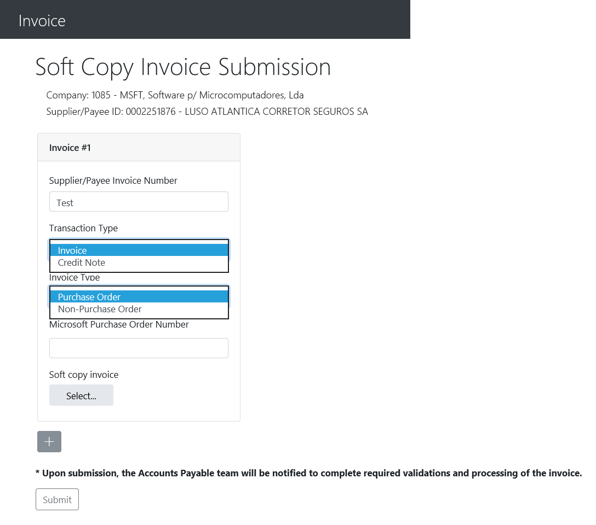

* Once submitted, the invoices will go directly to OCR via DMS (Auto sorting) based on the information mentioned in this screen